STATS 798 Notes

Research Masters

Junhuang Xue

Department of Statistics
The University of Auckland

Last Modified: Monday, 02/08/2018

Lecturer Information:

Professor Thomas Lumley
Office: 303S-325
Extension: 64 9 923 3785
Email: t.lumley@auckland.ac.nz
Office Hour: Booking

Contents

Forecasting: Principles and Practice - Rob J Hyndman and George Athanasopoulos (Ch 10) 3
Forecasting hierarchical time series - Rob J Hyndman 9
Definitions 10

Introduction to Bayesian Data Analysis with R (Baath 2015)
http://www.sumsar.net/files/academia/user_2015_tutorial_bayesian_data_analysis_short_version.pdf

What is Bayesian data analysis?

● It is when you use probability to represent uncertainty in all parts of a statistical model.

● A flexible extension of maximum likelihood.

● Potentially the most information-efficient method to fit a statistical model. (But potentially also the most computationally intensive method…)

Bayesian models as generative models
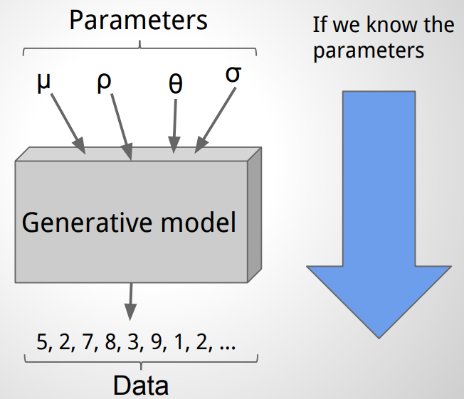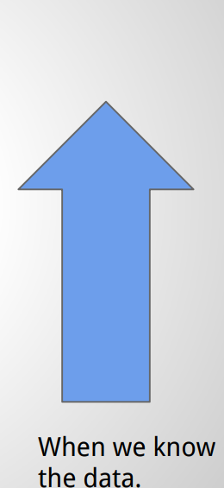

Example: Mark and Re-capture
1. Catch a couple of fish.
2. Mark them and throw them back.
3. At a later point, catch a couple of fish again.
4. Count how many are marked.

Why use Bayesian data analysis?

●You have great flexibility when building models, and can focus on that, rather than computational issues.

●You can include information sources in addition to the data, for example, expert opinion as prior.

● The result of a Bayesian analysis retains the uncertainty of the estimated parameters, which is very useful in decision analysis.

How to interpret and perform a Bayesian data analysis in R?

Priors
○ Objective priors
○ Subjective priors
○ Informative priors
○ Improper priors
○ Conjugate priors

R-codes for distributions

x ~ Normal(μ, σ) x <- rnorm(n_draw, mu, sd)
x ~ Binomial(p, n) x <- rbinom(n_draw, size, prob)
x ~ Poisson(λ) x <- rpois(n_draw, lambda)
x ~ Beta(α, β) x <- rbeta(n_draw, shape1, shape2)
x ~ Gamma(k, θ) x <- rgamma(n_draw, shape, scale)
Methods to generate posterior samples

Approximate Bayesian Computation (ABC)
Markov Chain Monte Carlo (MCMC)
● Metropolis-Hastings
● Gibbs Sampling
● Hamiltonian monte carlo

JAGS: Just Another Gibbs Sampler
a custom Gibbs sampler that can be called from R
A minimal JAGS program:
JAGS code
model {
n <- 30
p ~ dunif(0, 1)
x ~ dbinom(p, n)
}

R code
n <- 30
p <- runif(1, 0, 1)
x <- rbinom(1, p, n)

To summarize Bayesian data analysis

What?
● Bayesian data analysis is a flexible method to fit any type of statistical model.
● Maximum likelihood is a special case of Bayesian model fitting.

Why?
● Makes it possible to define highly custom models.
● Makes it possible to include information from many sources, for example, data and expert knowledge.
● Quantifies and retains the uncertainty in parameter estimates and predictions.

How?
● R! Using ABC, MCMCpack, JAGS, STAN, R-inla, etc.

